October Fly Tying Classes
4 Modules
Take one, two or all four.
Save money with ala carte option
$25/session Pay at class or prepay

Olympia Community Center Room
222 Columbia St. NW
Olympia, WA 98501

6:30 to 8:30 pm
Bring your own vice and tying tools

All hooks and material supplied by instructors
All instructors are professional fly tyers

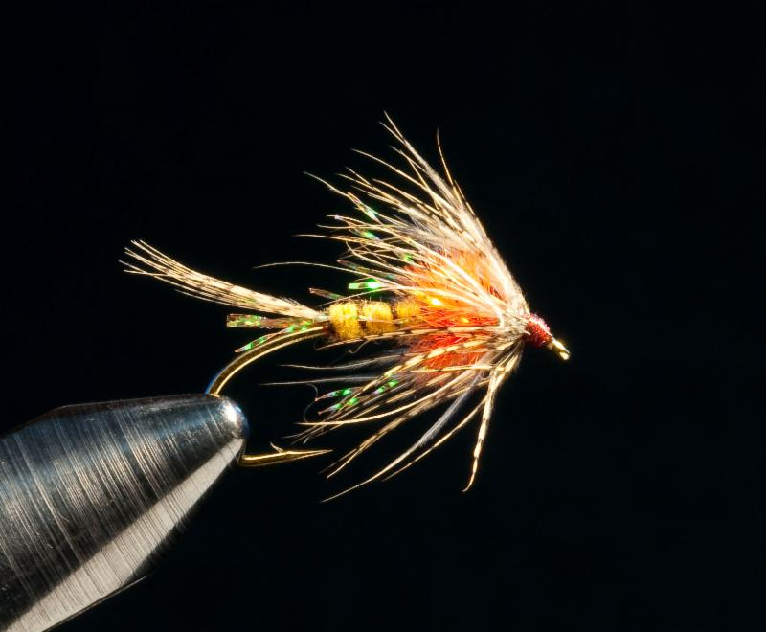
Mondays 6:30 to 8:30pm

Oct. 2 Janet Schimpf

Oct 9 Thomas Lamphere

Oct 15 Jay Paulson

Oct 23 Thomas Lamphere

